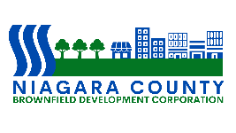

Niagara County Brownfield Development Corporation

BOARD OF DIRECTORS

Robert Restaino

Chairperson

Richard E. Updegrove

Vice Chairperson

Andrea L. Klyczek
Secretary

OFFICERS

Amy E. Schifferli
President

Margit Denning
Treasurer

P U B L I C N O T I C E
VIRTUAL MEETING

REGULAR MEETING OF THE
NCBDC BOARD OF DIRECTORS

A Regular Meeting of the Niagara County Brownfield Development Corporation will be held on Wednesday, March 4, 2026 at 1:00 p.m.

Dated: February 26, 2026

