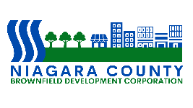

Niagara County Brownfield Development Corporation

BOARD OF DIRECTORS

Robert Restaino

Chairperson

Richard E. Updegrove

Vice Chairperson

Andrea L. Klyczek
Secretary

OFFICERS

Amy E. Schifferli
President

Margit Denning
Treasurer

P U B L I C N O T I C E
DECEMBER MEETING

ANNUAL MEETING OF THE
NCBDC BOARD OF DIRECTORS

The Annual Directors, Audit Committee and Membership meeting of the Niagara County Brownfield Development Corporation will be held on Thursday, December 18, 2025 at 9:00 a.m.

Dated: December 9, 2025

